Nuchar's Tomb v1.0 by Tenjac

This module contains only the tomb area, broken into two parts. Because of the tilesets, it was necessary to do this in order to have Nuchar's tomb area above water. A builder using this module will need to create the family mansion with a hidden access to Nuchar's Foyer. This would most likely be somewhere outside of town. The House on the Hill map from Libris Mortis could be a good candidate.

For ease of implementation, I'm going to reproduce the plot text from the source material here.

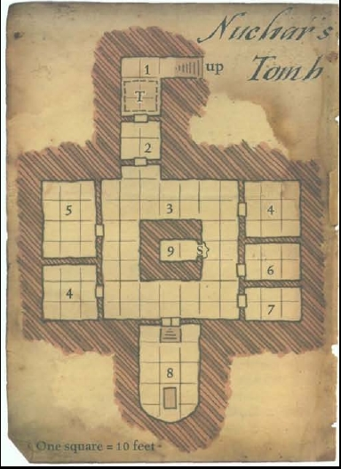
Few remember Nuchar. Nuchar's family was wealthy, and of noble blood, so when her questionable pursuits brought her low, her family hushed it up, and by virtue of merely sealing over her underground laboratory, which quieted the phantom screaming, muffled the unseen footsteps, and lessened the horrible shadows that sometimes appeared in the corners on the family estate.

This was not enough to save the family. A year and a day after Nuchar's laboratory (now called Nuchar's Tomb by the family) was sealed, a strange sickness struck the family, killing them all in mere hours. Afterward, the house, for all its grandiosity, would not sell. It fell into disrepair, and still stands abandoned today. Nuchar's Tomb remains a
name of mystery and horror. Stories of the wealth sealed away with Nuchar have also grow as time has passed. The stories might even be true.

Those who seek Nuchar's Tomb must navigate the decrepit house, find the secret stairs,
and descend to Nuchar's Foyer.

- Nuchar's Foyer - Sealed door, fire trap. Three feet of stagnant water.
- The Seal – Not much here aside from a monster and flooding.
- The Square – Yep... flooding. There's also a chest to be found.
- Abandoned Laboratories -
- Bone Assembly Room -
- Skinning Chamber – There are various torture devices here as well as lootable human flesh and another secret room not in the source.
- Cracked Crucible – This room contains a deadly flesh eating bacillus the party must be wary of.
- Nuchar's Tomb – Steps raise the majority of this room well above the flood level. Nuchar's coffin lies in this room. When a particularly vile spell snapped the thread of Nuchar's life, her corpse revived in the form of a deathlock. When intruders come into this room, she realizes the seal is breached. After dealing with the intruders, she will venture forth.
- Corrupted Well – This is where Nuchar's mother lies dead, strangled by her daughter's hand. Builders should take this into account or delete it.

Revision History

v1.0 Initial release.

